BERZERK

Aurelio Rodrigues

January 2024

Contents

Executive summary 3

Game Description 3

Overview 3

The Quest 4

Main Character 4

Sketch of Main Character 4

Opponents 5

Sketch of Opponents 5

Environment 6

Sketch of World 6

Menu 7

Controls 8

Sounds 9

Summary 9

# Executive summary

Berzerk is a cool classic game where you run around shooting robots and trying not to get hit. The goal is to stay alive and go through as many rooms as you can. You use a joystick to move and a button to shoot. It's easy to play, but it gets really hard because the robots get faster and more dangerous as you go on.

This game is for people who like old-school games, especially ones where you shoot a lot. It's not easy, so if you enjoy a challenge, this is for you. The game keeps changing each time you play, so it's always a surprise. The graphics are simple, with a basic grid and characters that give it an old-fashioned look. "Berzerk" is a fun game that brings back memories of the classic arcade era, and it's great for anyone who wants a simple, tough, and nostalgic gaming experience.

# Game Description

## Overview

Berzerk is an iconic video game that immerses players in an action-packed journey through dynamic rooms filled with menacing robots. Developed in the arcade era, this classic offers a compelling run-and-gun experience, combining simplicity in controls with escalating difficulty. The game's main objective is survival – players must navigate through various rooms, eliminate robots, and strive to progress as far as possible. With its straightforward gameplay mechanics and challenging adversaries, Berzerk caters to retro gaming enthusiasts, arcade shooter fans, and those seeking an adrenaline rush.

In this maze-like adventure, players control a character equipped with a joystick for movement and a fire button for shooting. The game's standout feature is its ever-increasing difficulty, with robots becoming faster and deadlier over time. This ensures a thrilling and challenging experience for players who appreciate classic arcade games. The visual style enhances the retro aesthetic, featuring stark, grid-based visuals and simple character sprites that contribute to the game's timeless charm.

Berzerk is designed for those who enjoy the satisfaction of overcoming tough challenges. As players progress through rooms, the maze layout changes with each playthrough, introducing an element of unpredictability. The main quest revolves around survival in the face of relentless robot adversaries, and the game's high difficulty level provides a sense of accomplishment for those who manage to navigate through its escalating challenges. With its engaging gameplay, Berzerk has become a cherished classic, standing as a testament to the enduring appeal of retro gaming experiences.

## The Quest

In Berzerk, the overarching quest centers around the player's survival within a maze-like structure infested with aggressive robots. The primary goal is to navigate through increasingly challenging rooms, eliminating robots while avoiding obstacles to reach the next stage. The game employs a level-based structure, with each stage introducing more formidable adversaries and intricate mazes.

Obstacles in the game include agile and deadly robots, hazardous elements within the rooms, and the ever-tightening confines of the maze. As players progress, the robots become faster and more aggressive, requiring heightened precision and strategic maneuvering to survive. The maze layout changes with each level, introducing an element of unpredictability that keeps the quest fresh and engaging.

Rewards in Berzerk are intrinsic to the challenge itself. Overcoming obstacles and successfully navigating through rooms provide a sense of accomplishment for the player. The satisfaction lies in surpassing one's previous achievements, as the difficulty intensifies with each level. There are no explicit rewards in terms of power-ups or upgrades, emphasizing the purity of skill and strategy required to progress.

The final objective is to survive as long as possible, pushing the limits of skill and endurance. Unlike narrative-driven games with a definitive endpoint, Berzerk challenges players to outlast the relentless onslaught of robots, striving for a higher score and a coveted spot on the game's leaderboard. The absence of a traditional narrative lends itself to a gameplay-focused experience, where the thrill lies in the journey of overcoming obstacles rather than a predetermined conclusion.

## Main Character

The main character is a soldier. It wears a uniform and carries a gun.

As the main character progresses through the game, its skills evolve, and it gains access to a super weapon, a game-changer in battles.

In addition, players experience the soldier's journey in a third-person perspective.

## Sketch of Main Character

## Opponents

In Berzerk, there are a bunch of robots that come in same shapes and sizes. In each scene, the robots will show some different gaming skills, though.

These robots shoot bullets in the direction of the player and move around the scene. As you keep playing, the robots get faster and can fire faster bullets.

## Sketch of Opponents

## Environment

The environment of Berzerk is scenes with different mazes. The maze starts on the left and goes to the right, and it is made up of walls that you need to navigate through.

The background is black, giving an impression of darkness. On the other hand, the player can see the opponents and walls.

The visuals are simple, respecting a classic arcade vibe. To sum up, the maze changes with different patterns according to the scenes the player is in.

## Sketch of World

## Menu

The Menu of the game is composed with a bold title "Berzerk", a "Start Game", "Credits," and "Exit Game" buttons.

Clicking on “Start Game”, the player is lead into the begin of the game. In credits, there are some relevant information about the developer and the game itself. The button “Exit Game” leads the player to leave the game, finishing up its execution.

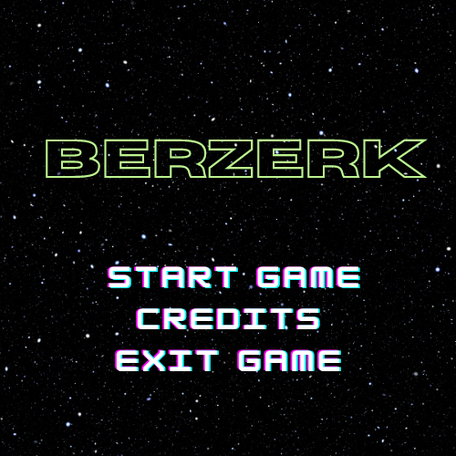

## Controls

The controls for Berzerk are super simple, being just needed to have a keyboard, and a mouse. See the controls:

* Press the arrow key up or W to movie the character to up.
* Press the arrow key down or S to movie the character to down.
* Press the arrow key left or A to movie the character to left.
* Press the arrow key right or D to movie the character to right.
* Press Space or left click on the mouse to fire bullets.
* Press Enter or right click on the mouse to fire super weapon.
* Press the Escape to pause the game.

## Sounds

The background music sets the tone. As the player traverses the maze, the character's footsteps echo through the grid.

There are sounds for bullets either. When the character fires a simple bullet, its specific sound is played. Besides, a different sound is played when the special weapon is used.

To wrap up, Berzerk contains sounds when the character move to another stage and when it dies.

# Summary

Embark on an electrifying journey with Berzerk, the ultimate retro arcade game that promises non-stop action and nostalgic vibes! In Berzerk, you are not just playing a game; you are experiencing a symphony of sights and sounds that transport you to the singular age of gaming. Engage in intense run-and-gun gameplay with simple controls to navigate through the maze of rooms filled with futuristic foes.

Challenge your skills as you progress through levels, with enemies growing faster and deadlier, keeping you on the edge of your seat. Are you up for the adrenaline-pumping action that Berzerk delivers?

Get ready to press start and dive into the heart-pounding adventure of Berzerk – where every move counts, every shot matters, and every level brings you closer to arcade victory! Do not miss your chance to own this classic-inspired game that captures the essence of gaming's golden era.